**Project: Coffee Shop Management System**

|  |
| --- |
| Name |
| Akib Muhammad |

**Introduction**

A coffee shop is the best place to pass one’s free time. There are a lot of people who love coffee more than any other drinks. Usually, in a coffee shop the interior is well designed and it’s calm and quiet. People go there not only to drink coffee but also to read books, to meet new people and to finish their job related works. Every coffee shop has a management system. Before starting the shop they plan the whole thing and then gives that plan a real form. So, our project is about that management system.

Behind every coffee shop which is big or small there’s an **owner** who **owns** the the coffee shop. That owner gathers up the courage to invest big time or small time and depending on that investment the coffee shop becomes big or small. The owner needs his background clean and so to verify that the authority runs a check on his id so there’s idattribute(**owner_ID**) and for the coffee shop it needs to have a id of being registered and so there’s **reg_Id** attribute. In terms of coffee shop, it has to be made in a well known area where it can get a lot of customers. In order to visit there the customers need the address so there’s **address** attribute. If the customers are from out of the city then they have to ask people to know about its location and for that reason there’s the **name** attribute. Then to know about the status of the coffee shop whether it is opened or closed customer needs source to contact and based on that fact there’re two attributes namely **phone** and **email**. After that he **appoints** **manager and employees** since he can’t be at the coffee shop all the time the manager takes care of everything on behalf of the owner. For hiring the manager and employees the owner needs to make sure that they don’t have any criminal records and so he runs and check on both manger’s and employees **id** before hiring. Then after he finds out that they are clean, they provide the owner their **names**, **addresses**, **phone(multivalued attribute)** and **email**. When the owner realizes that the employees are qualified for the job he then offers them **salary** and notes down their **hiredate**. To know about the status of the coffee shop the owner needs to contact the manager and so they both have a **multivalued attribute** which is **phone**. If that’s unreachable then **address** attribute is also there. If the owner’s gone abroad and the manager needs to report a serious issue then he can use the **email** attribute .Then the **manager** **manages** those **employees** to provide the best service towards the customers which the **customers expect**. After that the employees start the day according to the plan. The customers arrives at the coffee shop the employees note down their desired drink or dessert. After they are done the bills are made according to the customer’s name(**C_Name**) and id(**C_ID**). The **bill** entity contains **amount**, **bill_id** and **visitation_date** attributes.

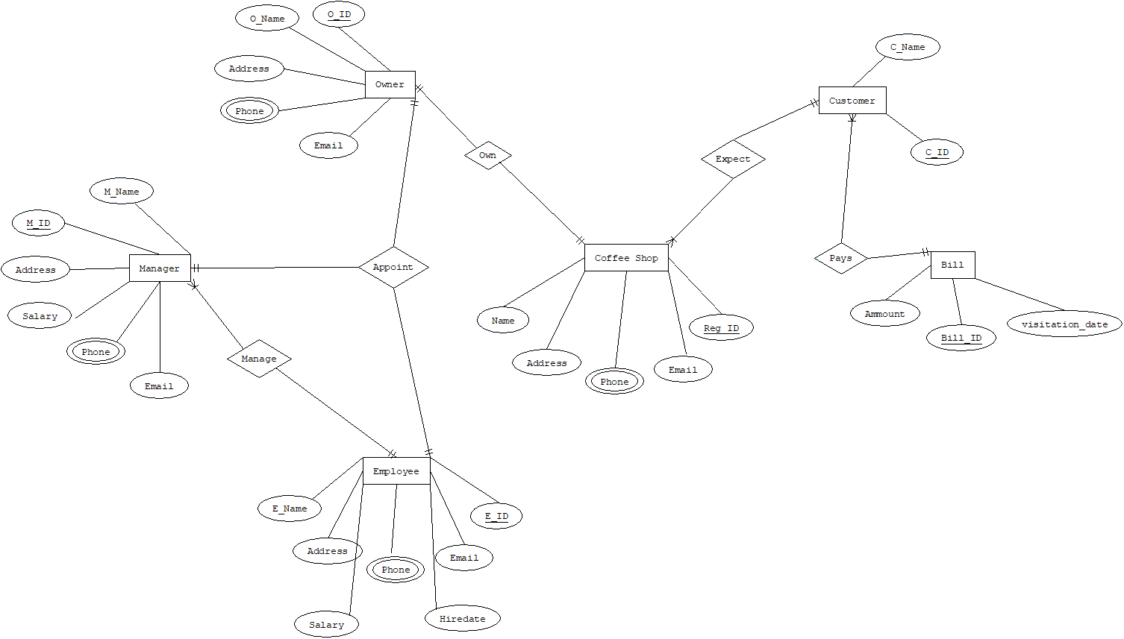

**Normalization**

Own - (Name, Reg_ID,Address,Email,Phone,O_ID,O_Name,Address,Email,Phone)

1NF- Phone is a multivalued attribute

2NF- Name,Reg_ID,Address,Email,Phone

O_ID,O_Name,Address,Email,Phone

3NF- Name,Reg_ID,Address,Email,Phone

O_ID,O_Name,Address,Email,Phone

Table for Own

1. Name,Reg_ID,Address,Email,O_ID (O_ID is the foreign key)

2. O_ID,O_Name,Address,Email

3. Reg_ID,phone -composite pk

4. O_ID,phone -composite pk

Expect- (C_name,C_ID,Name,Reg_ID,Address,Email,Phone)

1NF- Phone is a multivalued attribute

2NF- C_name,C_ID

Name,Reg_ID,Address,Email,Phone

3NF- C_name,C_ID

Name,Reg_ID,Address,Email,Phone

Table for Expect

1. C_name,C_ID,Reg_ID (Reg_ID is the foreign key)

2. Name,Reg_ID,Address,Email,Phone

3. Reg_ID,phone -composite pk

Pays- (C_name,C_ID,Bill_ID,Ammount,visitation_date)

1NF- There is no multrivalued attribute

2NF- C_name,C_ID

Bil_ID,Ammount,visitation_date

3NF- C_name,C_ID

Bil_ID,Ammount,visitation_date

Table for Pays-

1. C_name,C_ID,Bill_ID (Bill_ID is the foreign key)

2. Bil_ID,Ammount,visitation_date

Manage - (E_Name,E_ID,Address,Email,Salary,Hiredate,Phone,M_Name,M_ID,Address,Email,Salary,Phone)

1NF- Phone is a multivalued attribute

2NF- E_Name,E_ID,Address,Email,Salary,Hiredate,Phone

M_Name,M_ID,Address,Email,Salary,Phone

3NF- E_Name,E_ID,Address,Email,Salary,Hiredate,Phone

M_Name,M_ID,Address,Email,Salary,Phone

Table for Manage

1. E_Name,E_ID,Address,Email,Salary,Hiredate,M_ID (M_ID is the foreign key)

2. M_Name,M_ID,Address,Email,Salary

3. E_ID,Phone -composite pk

4. M_ID,Phone -composite pk

Appoint - (E_Name,E_ID,Address,Email,Salary,Hiredate,Phone,M_Name,M_ID,Address,Email,Salary,Phone,O_ID,O_Name,Address,Email,Phone)

1NF- Phone is a multivalued attribute

2NF- E_Name,E_ID,Address,Email,Salary,Hiredate,Phone

M_Name,M_ID,Address,Email,Salary,Phone

O_ID,O_Name,Address,Email,Phone

3NF- E_Name,E_ID,Address,Email,Salary,Hiredate,Phone

M_Name,M_ID,Address,Email,Salary,Phone

O_ID,O_Name,Address,Email,Phone

Table for Appoint

1. E_Name,E_ID,Address,Email,Salary,Hiredate,M_ID,O_ID (M_ID,O_ID is the foreign key)

2. M_Name,M_ID,Address,Email,Salary

3. O_ID,O_Name,Address,Email

4. E_ID,Phone -composite pk

5. M_ID,Phone -composite pk

6. O_ID,phone -composite pk

Final Table

1. Name,Reg_ID,Address,Email,O_ID - CShop

2. C_name,C_ID,Reg_ID -CustomerC

3. C_name,C_ID,Bill_ID -CustomerB

4. E_Name,E_ID,Address,Email,Salary,Hiredate,M_ID,O_ID - Employee

5. Bil_ID,Ammount,visitation_date - Bill

6. O_ID,O_Name,Address,Email - Owner

7. M_Name,M_ID,Address,Email,Salary -Manager

8. Reg_ID,phone - R_fn

9. O_ID,phone - O_fn

10. E_ID,Phone - E_fn

11. M_ID,Phone - M_fn

**Create Table**

create table CShop(

name varchar2(20),

reg_id number(10),

address varchar2(30),

email varchar2 (20),

O_ID number(10))

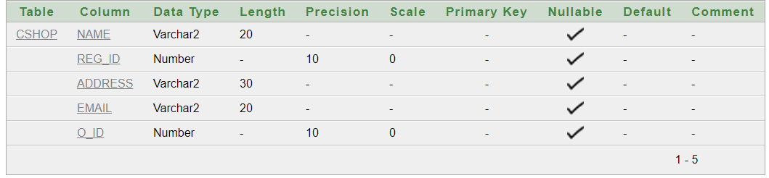

alter table CShop add constraint cx1 primary key (reg_id)

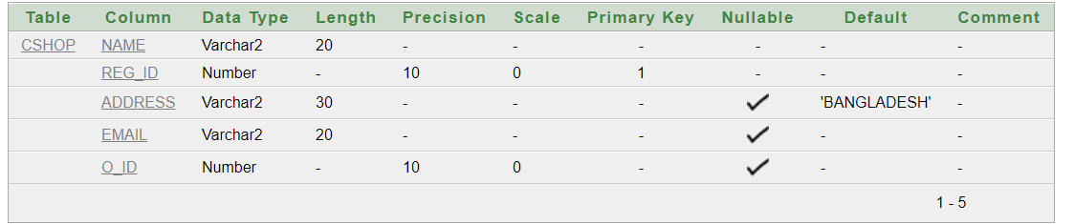

alter table CShop modify(name not null)

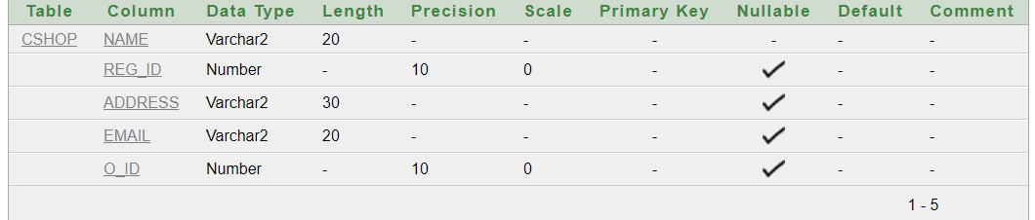

alter table CShop add constraint cx2 unique (email)

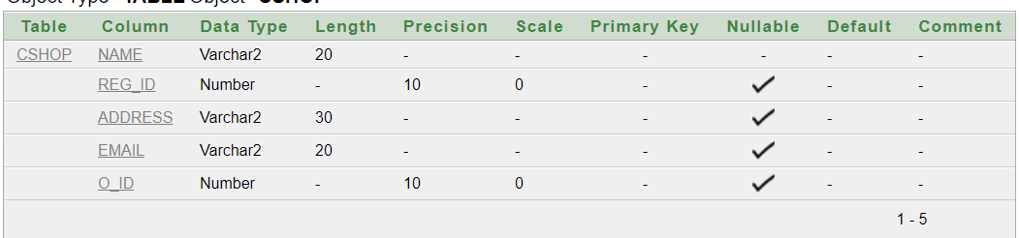

alter table CShop modify address default 'BANGLADESH'

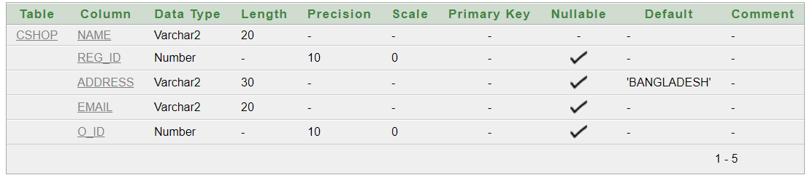

create table Owner(

O_ID number(10),

O_Name varchar2(20),

address varchar2(30),

email varchar2 (20))

alter table Owner add constraint cx3 primary key(O_ID)

alter table CShop add constraint cx4 foreign key(O_ID) references Owner(O_ID)

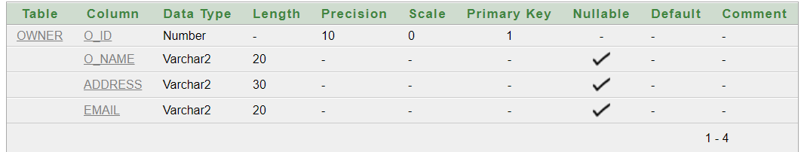

create table O_fn(

O_ID number(15),

phone number(20))

alter table O_fn add constraint cx5 primary key(O_ID,phone)

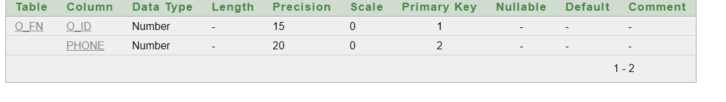

create table reg_fn(

reg_id number(15),

phone number(20))

alter table reg_fn add constraint cx17 primary key(reg_id,phone)

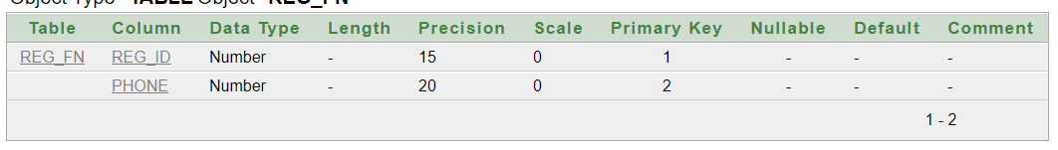

create table CustomerC(

C_ID number(10),

C_Name varchar2(20),

reg_id number(10))

alter table CustomerC add constraint cx6 primary key(C_ID)

alter table CustomerC add constraint cx7 foreign key(reg_id) references CShop(reg_id)

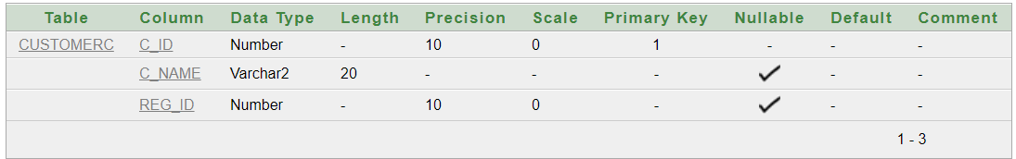

create table CustomerB(

C_ID number(10),

C_Name varchar2(20),

bill_id number(10))

alter table CustomerB add constraint cx8 primary key(C_ID)

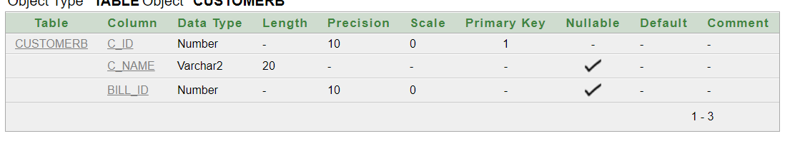

create table Bill(

bill_id number(10),

ammount varchar2(20),

visitation_date date)

alter table Bill add constraint cx9 primary key(bill_id)

alter table CustomerB add constraint cx10 foreign key(bill_id) references Bill(bill_id) 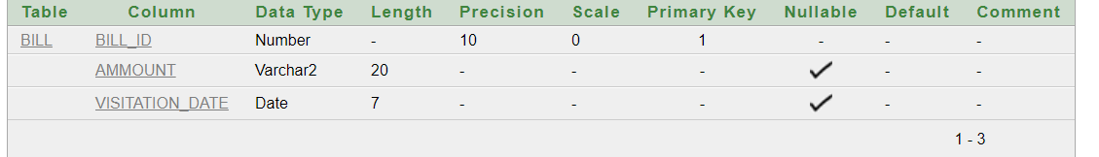

create table Employee(

E_ID number(10),

E_Name varchar2(20),

address varchar2(30),

email varchar2 (20),

sal number (7,2),

hiredate date,

M_ID number(10),

O_ID number (10))

alter table Employee add constraint cx11 primary key(E_ID)

alter table Employee add constraint cx12 foreign key(O_ID) references Owner(O_ID)

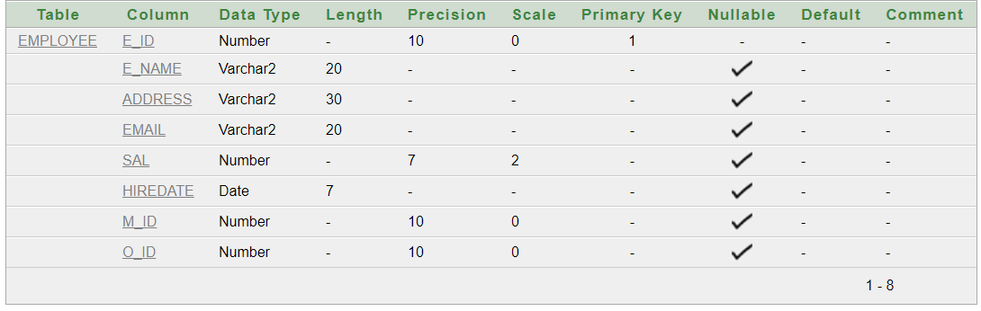

create table Manager(

M_ID number(10),

M_Name varchar2(20),

address varchar2(30),

email varchar2 (20),

sal number (7,2))

alter table Manager add constraint cx13 primary key(M_ID)

alter table Employee add constraint cx14 foreign key(M_ID) references Manager(M_ID)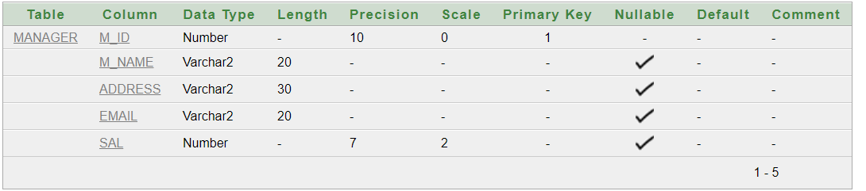

create table E_fn(

E_ID number(15),

phone number(20))

alter table E_fn add constraint cx15 primary key(E_ID,phone)

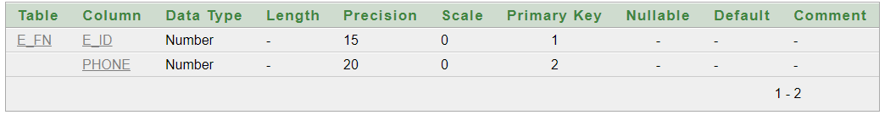

create table M_fn(

M_ID number(15),

phone number(20))

alter table M_fn add constraint cx16 primary key(M_ID,phone)

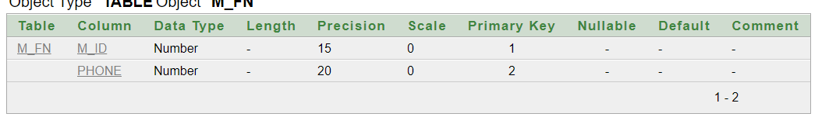

**Data Input**

insert into CShop values('ChitChat House',101,'Bashundhara','chitchat@gmail.com',201)

select *

from cshop

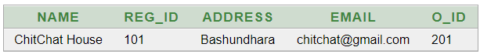

insert into Owner values(201,'Nasif Hasan Khan','Bashundhara','noyel.nhk@gmail.com')

select *

from owner



insert into O_fn values(201,01705655655)

select *

from o_fn

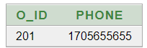

insert into reg_fn values(101,01705655655)

select *

from reg_fn

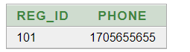

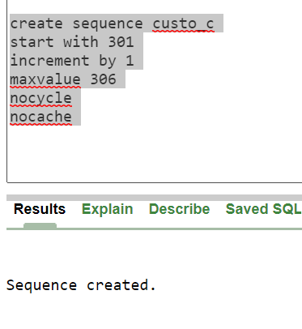

insert into customerc (c_id,c_name,reg_id) values (custo_c.nextval,'Rafi',101)

insert into customerc (c_id,c_name,reg_id) values (custo_c.nextval,'Tafi',101)

insert into customerc (c_id,c_name,reg_id) values (custo_c.nextval,'Akib',101)

insert into customerc (c_id,c_name,reg_id) values (custo_c.nextval,'Nasif',101)

insert into customerc (c_id,c_name,reg_id) values (custo_c.nextval,'Noyel',101)

select *

from customerc

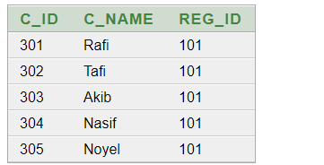

insert into bill values (401,400,to_date('17-12-2020','dd-mm-yyyy'))

insert into bill values (402,250,to_date('18-12-2020','dd-mm-yyyy'))

insert into bill values (403,700,to_date('19-12-2020','dd-mm-yyyy'))

insert into bill values (404,670,to_date('20-12-2020','dd-mm-yyyy'))

insert into bill values (405,425,to_date('21-12-2020','dd-mm-yyyy'))

select *

from bill

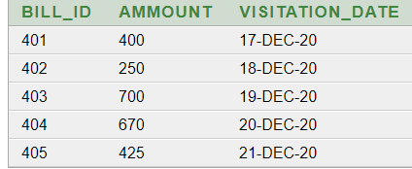

insert into customerb values (301,'Rafi',401)

insert into customerb values (302,'Tafi',402)

insert into customerb values (303,'Akib',403)

insert into customerb values (304,'Nasif',404)

insert into customerb values (305,'Noyel',405)

select *

from customer

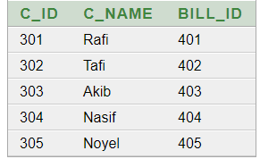

insert into manager values (501,'Tawhid Hasan','Mohakhali','tawhidrafi@gmail.com',10000)

select *

from manager

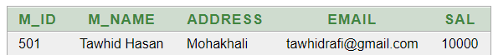

insert into employee values (601,'Rahim','Kuratoli',Null,1500,to_date('15-12-2020','dd-mm-yyyy'),501,201)

insert into employee values (602,'Karim','Nikunjo',Null,1500,to_date('15-12-2020','dd-mm-yyyy'),501,201)

insert into employee values (603,'Joynal','Bashundhara','joynal92@gmail.com',1500,to_date('15-12-2020','dd-mm-yyyy'),501,201)

select *

from employee

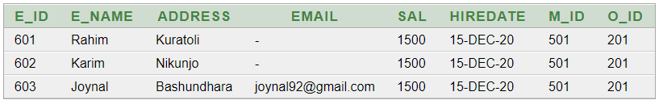

insert into m_fn values (501,01654783219)

select *

from m_fn



**Questions**

1. **FIND OUT E MANAGER NAME AND SALARY FROM EMPLOYEE TABLE.**
2. **FIND OUT CUSTOMER ID AND NAME FROM COFFESHOP.**
3. **create a view in owner table.**
4. **FIND OUT NAME AND SALARY WHOSE SALARY IS GREATER THAN EMPLOYEE ID =603.**
5. **find out customer name, Bill, amount and visitation date.**
6. **show all information about coffee shop (relational algebra).**
7. **FIND OUT owner’s all information FROM COFFESHOP.**
8. **create a table fop only customer id and customer name.**
9. **add menu COLUMN ON Bll table.**
10. **find out an employee name whose name start with j.**